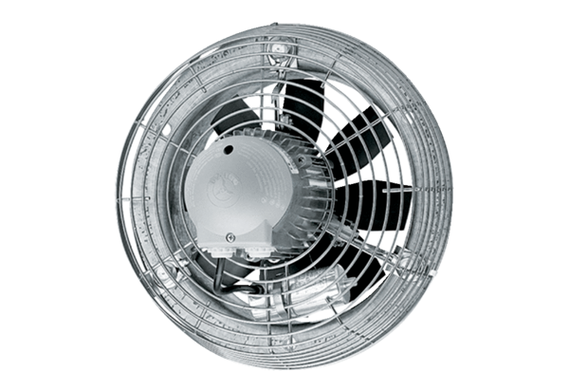Axial wall fan EZS 30/2 BPacking unit: 1 pieceRange: C
Article number: 0094.0004Manufacturer: MAICO

