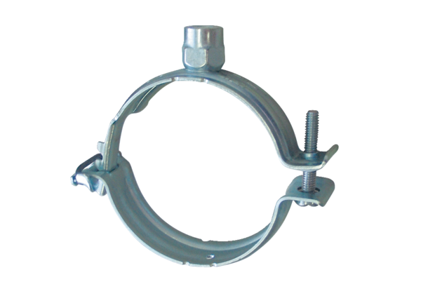Mounting clamp MF-S63Packing unit: 1 pieceRange: K
Article number: 0018.0471Manufacturer: MAICO

