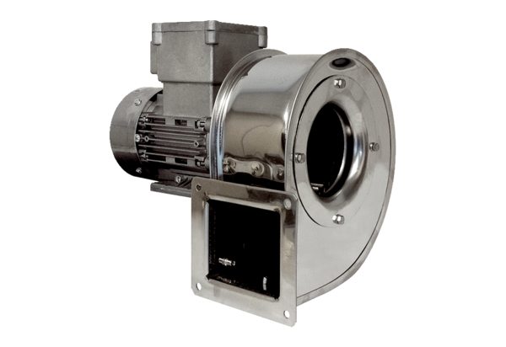Centrifugal blower GRM ES 12/2 ExPacking unit: 1 pieceRange: C
Article number: 0073.0392Manufacturer: MAICO

