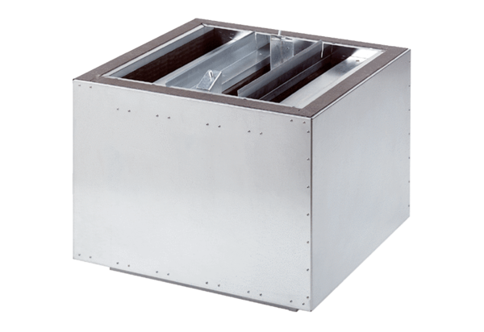Exhaust air silencer SDA 31Packing unit: 1 pieceRange: C
Article number: 0092.0388Manufacturer: MAICO

