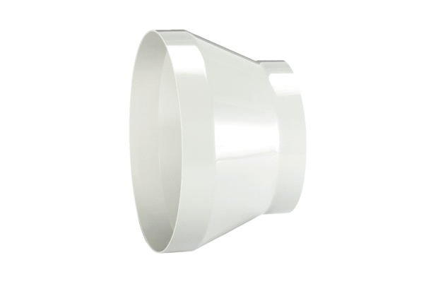Reducer REM 25/20Packing unit: 1 pieceRange: C
Article number: 0059.0636Manufacturer: MAICO

