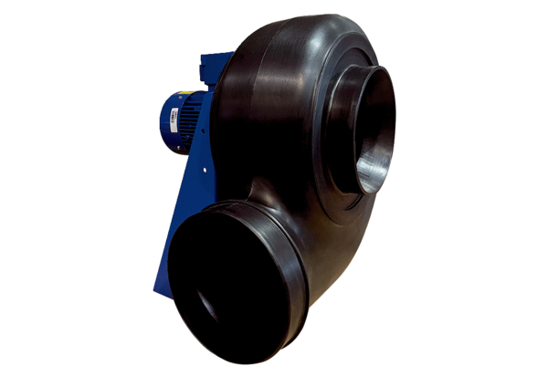Centrifugal blower GRK R 63/6 D ExPacking unit: 1 pieceRange: C
Article number: 0073.0461Manufacturer: MAICO

