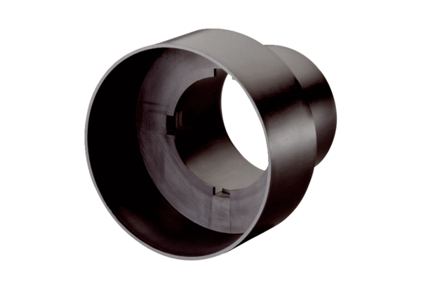Valve adaptor MF-A63Packing unit: 1 pieceRange: K
Article number: 0059.0965Manufacturer: MAICO

