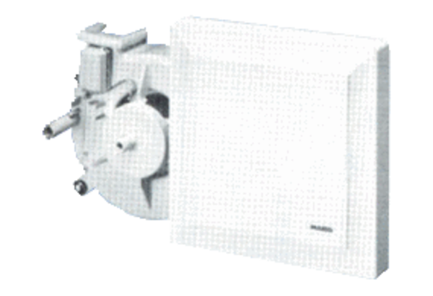Fan insert ER 17/60-2 GPacking unit: 1 pieceRange:
Article number: 0080.0786Manufacturer: MAICO

