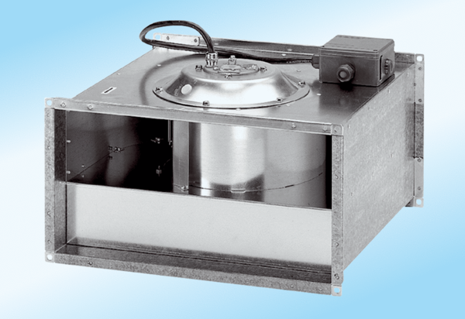Channel fan DPK 22/4 ExPacking unit: 1 pieceRange: D
Article number: 0086.0640Manufacturer: MAICO

