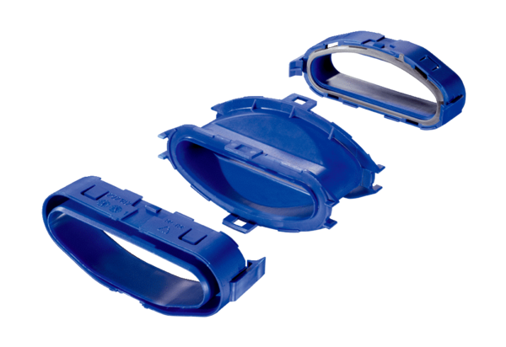Transition piece for 180° rotation FFS-Ü180Packing unit: 1 pieceRange: K
Article number: 0055.0879Manufacturer: MAICO

