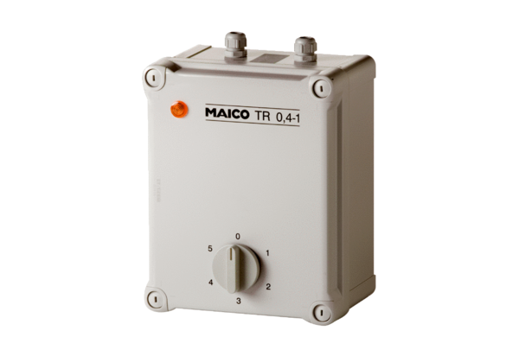5-step transformer TR 0,4-1Packing unit: 1 pieceRange: C
Article number: 0157.0370Manufacturer: MAICO

