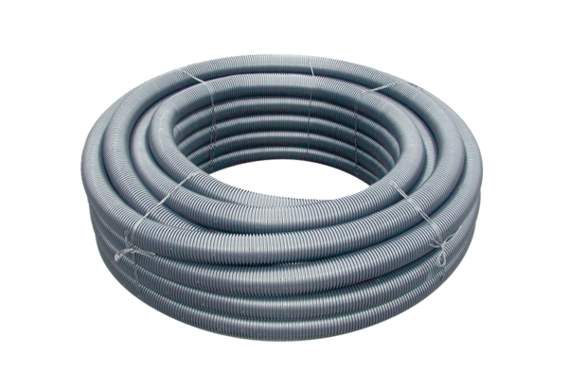Flexible duct MF-F90Range: K
Article number: 0055.0095Manufacturer: MAICO

