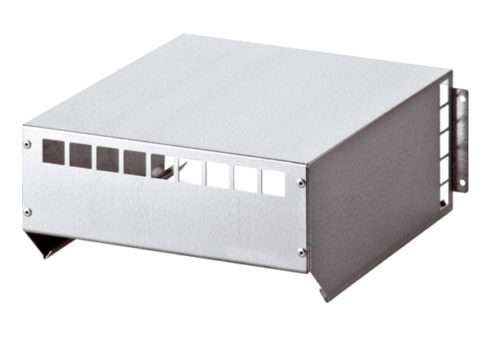Weather protection roof WSD 20-40Packing unit: 1 pieceRange: C
Article number: 0149.0083Manufacturer: MAICO

