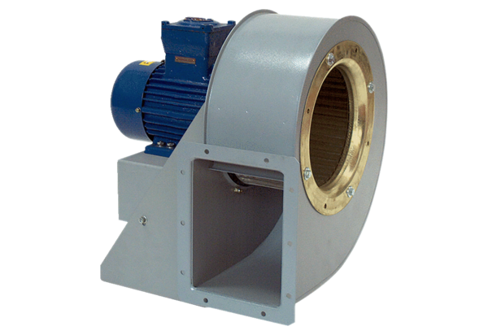Centrifugal blower GRM HD 35/8 ExPacking unit: 1 pieceRange: C
Article number: 0073.0412Manufacturer: MAICO

