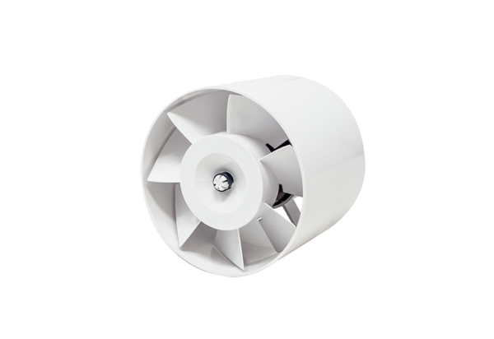Duct-mounted fan ERV 120Packing unit: 1 pieceRange: A
Article number: 0080.0984Manufacturer: MAICO

