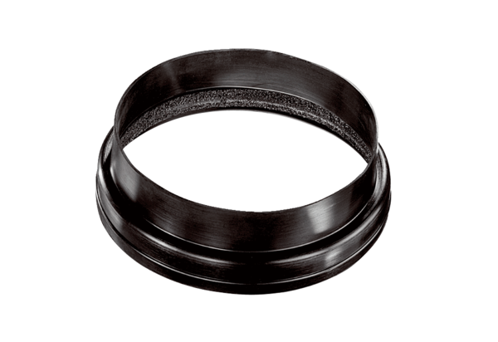Ventilation duct coupling MT-Ü180Packing unit: 1 pieceRange: K
Article number: 0059.0989Manufacturer: MAICO

