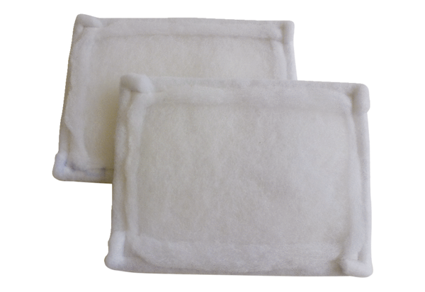Air filter, replacement FE 16-1Packing unit: 2 piecesRange: C
Article number: 0093.1224Manufacturer: MAICO

