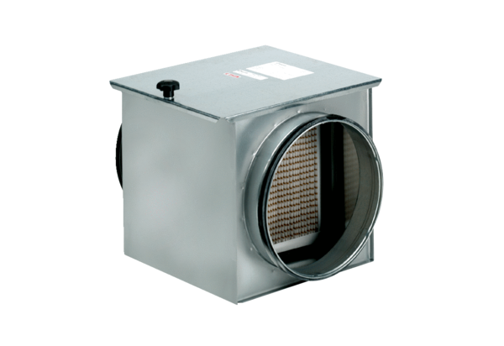Air filter TFE 25-7Packing unit: 1 pieceRange: C
Article number: 0149.0054Manufacturer: MAICO

