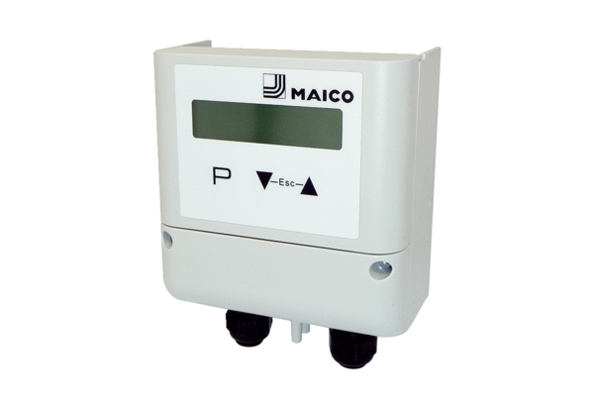Pressure controller DS MDR-PG AVCPacking unit: 1 pieceRange: E
Article number: E157.1636.0000Manufacturer: MAICO

