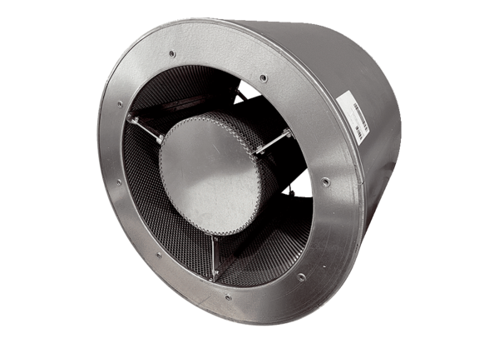Tubular sound absorber RSKI 71/1500Packing unit: 1 pieceRange: C
Article number: 0073.0113Manufacturer: MAICO

