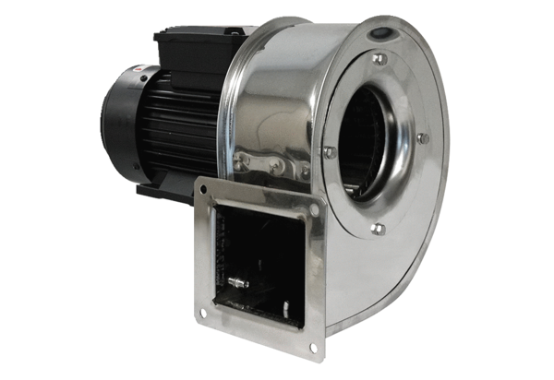Centrifugal blower GRM ES 16/2 EPacking unit: 1 pieceRange: C
Article number: 0073.0319Manufacturer: MAICO

