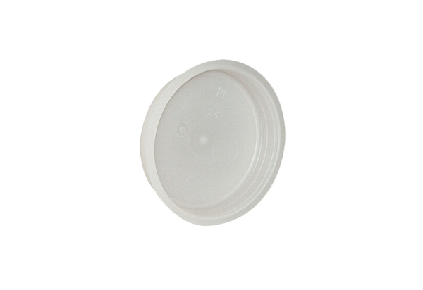End plug MF-FST90Packing unit: 10 piecesRange: K
Article number: 0059.0978Manufacturer: MAICO

