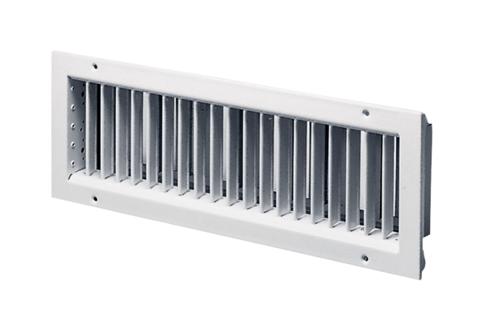Internal grille LGZ 62/22Packing unit: 1 pieceRange: D
Article number: 0151.0265Manufacturer: MAICO

