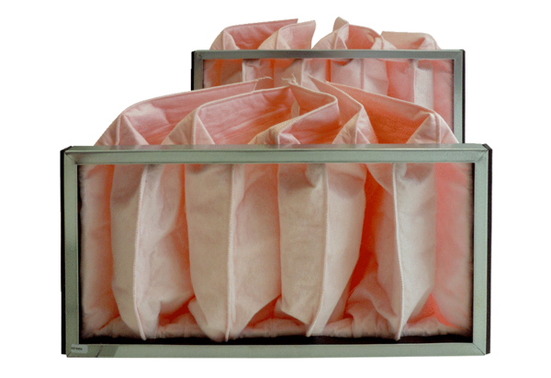Air filter, replacement KF 28-7Packing unit: 2 piecesRange: D
Article number: 0093.0865Manufacturer: MAICO

