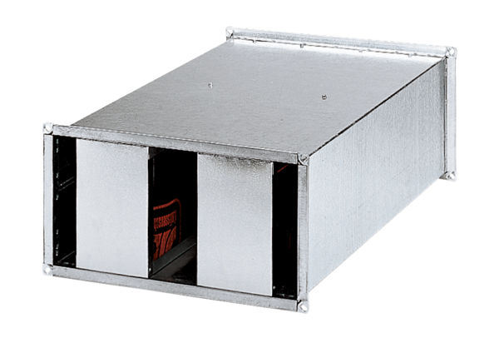Channel sound absorber KSP 22/15Packing unit: 1 pieceRange: D
Article number: 0092.0301Manufacturer: MAICO

