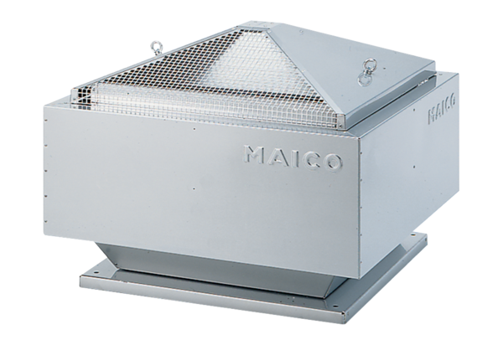Centrifugal roof fan DRD 40/64 BPacking unit: 1 pieceRange: C
Article number: 0087.0153Manufacturer: MAICO

