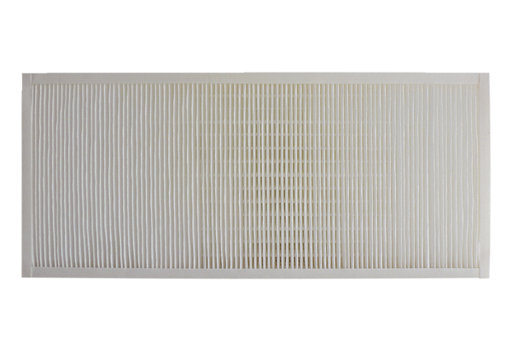Air filter, replacement KFF 9030-7Packing unit: 1 pieceRange: K
Article number: 0093.1219Manufacturer: MAICO

