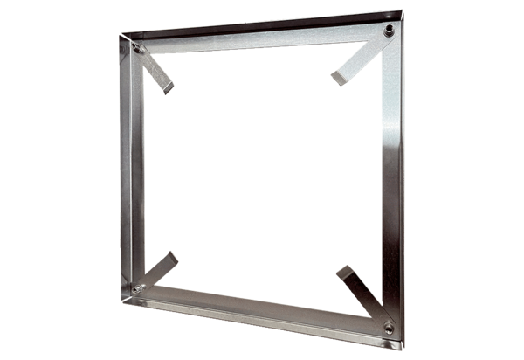Installation frame MRI 63-75-80Packing unit: 1 pieceRange: C
Article number: 0073.0043Manufacturer: MAICO

