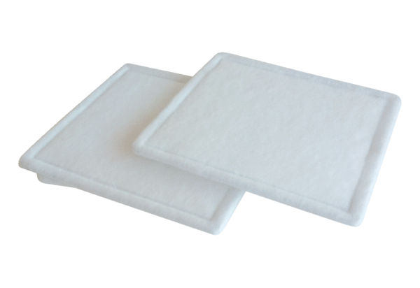Air filter, replacement RF 40-4Packing unit: 2 piecesRange: C
Article number: 0093.0163Manufacturer: MAICO

