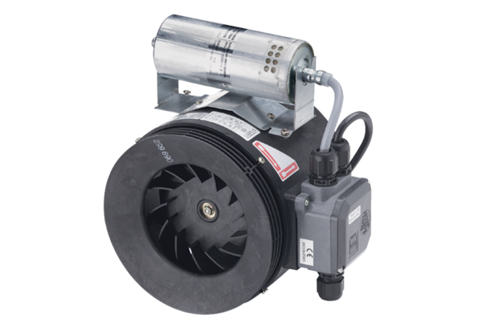Semi-centrifugal duct fan ERM 25 Ex tPacking unit: 1 pieceRange: C
Article number: 0080.0468Manufacturer: MAICO

