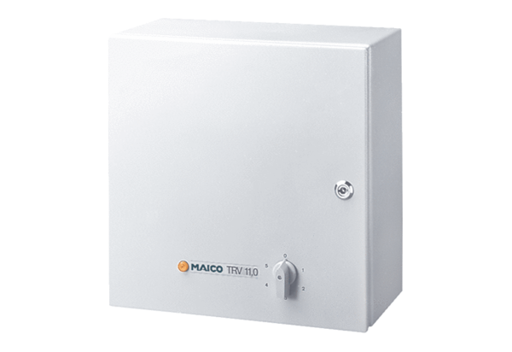5-step transformer TRV 11,0Packing unit: 1 pieceRange: C
Article number: 0157.0719Manufacturer: MAICO

