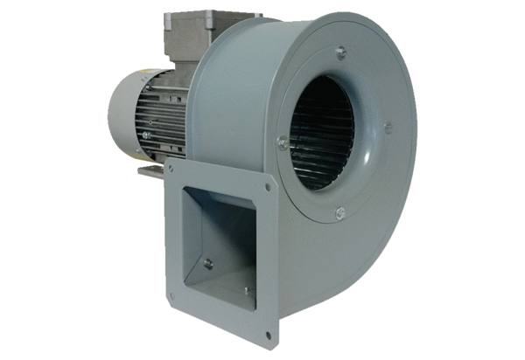Centrifugal blower GRM 12/2 D ExPacking unit: 1 pieceRange: C
Article number: 0073.0387Manufacturer: MAICO

