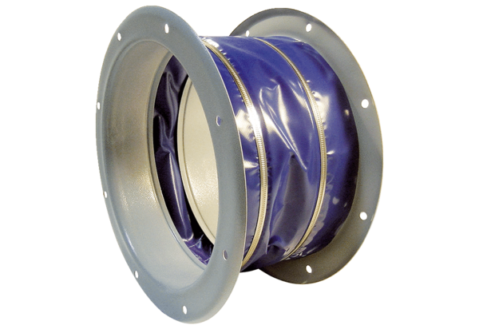Flexible coupling ELI 125Packing unit: 1 pieceRange: C
Article number: 0073.0224Manufacturer: MAICO

