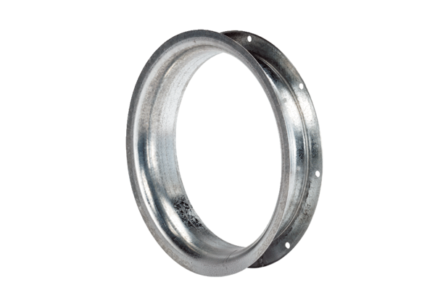Suction nozzle AD 40Packing unit: 1 pieceRange: C
Article number: 0180.0623Manufacturer: MAICO

