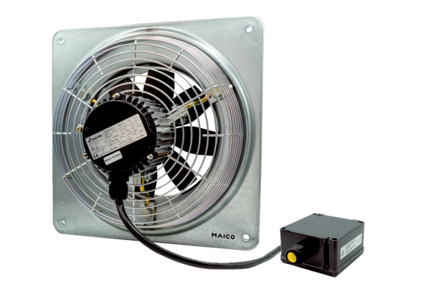Axial wall fan DZQ 30/2 B Ex tPacking unit: 1 pieceRange: C
Article number: 0083.0206Manufacturer: MAICO

