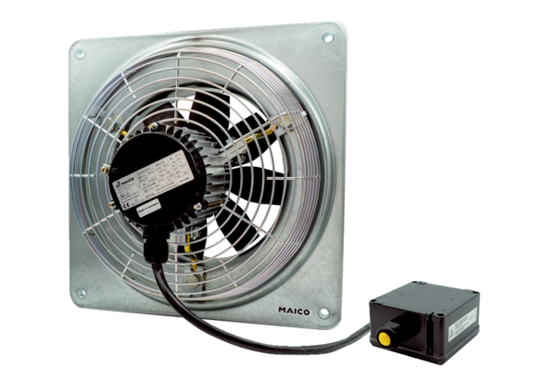Axial wall fan DZQ 60/6 B Ex ePacking unit: 1 pieceRange: C
Article number: 0083.0186Manufacturer: MAICO

