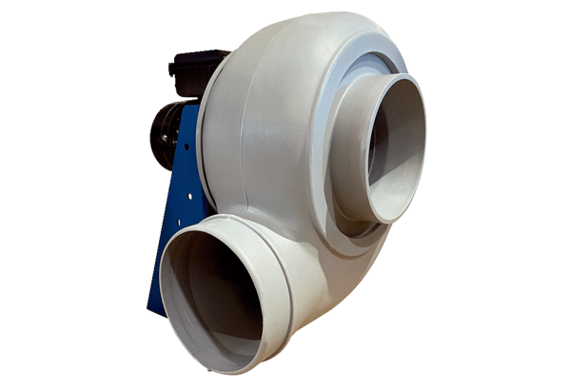Centrifugal blower GRK R 25/4 EPacking unit: 1 pieceRange: C
Article number: 0073.0506Manufacturer: MAICO

