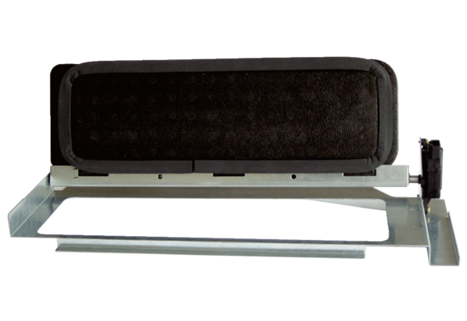Bypass for heat exchanger WS-BPR 320/470Packing unit: 1 pieceRange: K
Article number: 0093.1577Manufacturer: MAICO

