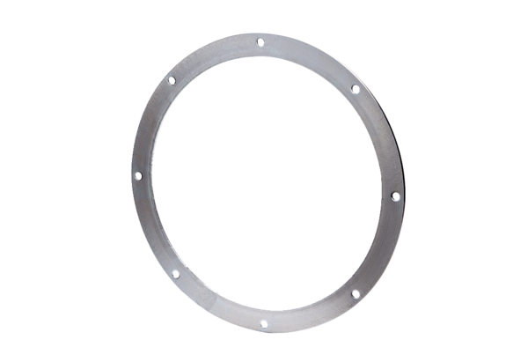Counter flange GF 56Packing unit: 1 pieceRange: C
Article number: 0056.0010Manufacturer: MAICO

