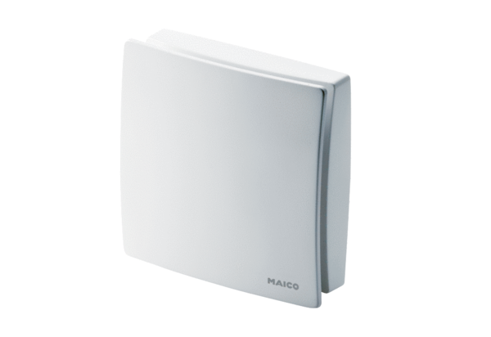Cover ABD ECA 150 ipro 1Range: A
Article number: E059.1502.9001Manufacturer: MAICO

