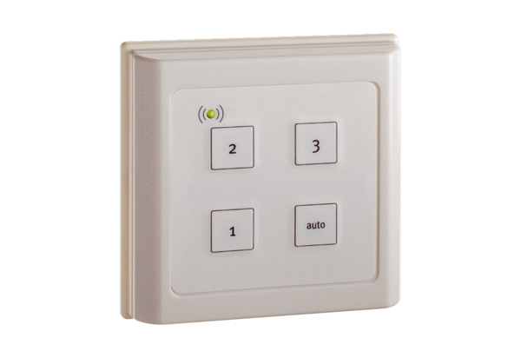Room air control ZEG EC-FBPacking unit: 1 pieceRange: K
Article number: 0157.0411Manufacturer: MAICO

