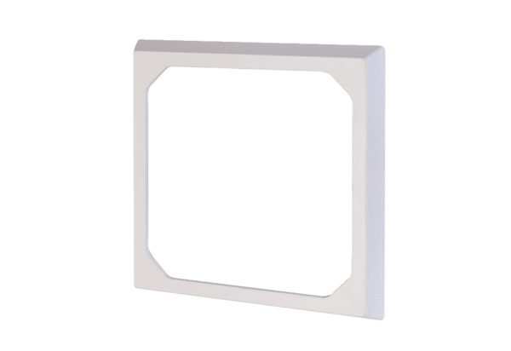Masking frame ER-AR ECPacking unit: 1 pieceRange: B
Article number: 0093.0276Manufacturer: MAICO

