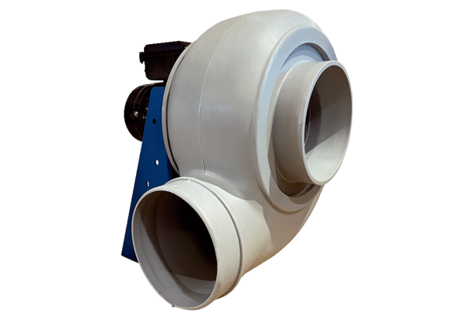Centrifugal blower GRK R 31/4 DPacking unit: 1 pieceRange: C
Article number: 0073.0519Manufacturer: MAICO

