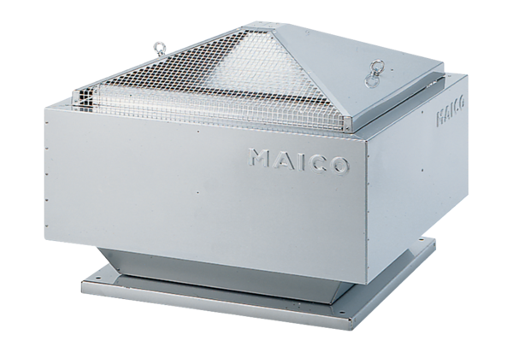Centrifugal roof fan MDR 22 ECPacking unit: 1 pieceRange: E
Article number: 0087.0022Manufacturer: MAICO

