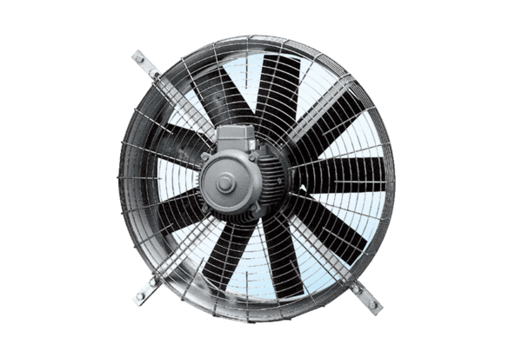Axial wall fan DZQ 100/8Packing unit: 1 pieceRange: C
Article number: 0083.0647Manufacturer: MAICO

