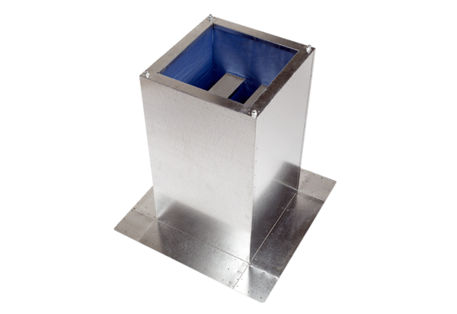Socket sound absorber SD 63Packing unit: 1 pieceRange:
Article number: 0092.0346ALTManufacturer: MAICO

