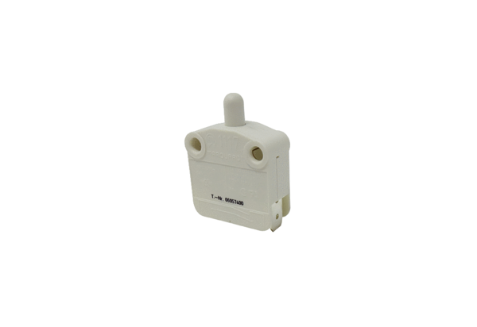Door contact switch TS 1<data>
<p class="FT">Range:</p>
</data>
K
<data>
<p class="FT">Article number:</p>
</data>
E157.1150.0000<data>
<p class="FT">Manufacturer:</p>
</data>
MAICO

