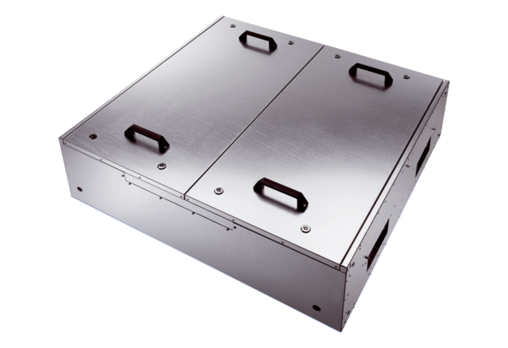Sound-insulated Flatbox for supply air with two air filters KFD 9040-FPacking unit: 1 pieceRange: K
Article number: 0080.0890Manufacturer: MAICO

