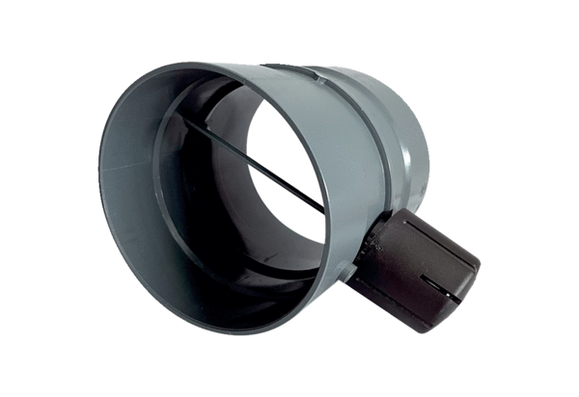Manual throttle valve MDKI 50Packing unit: 1 pieceRange: C
Article number: 0073.0487Manufacturer: MAICO

