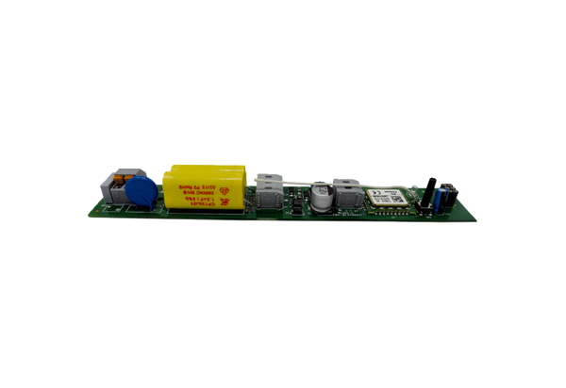Circuit board PL ECA 150 ipro RCRange: A
Article number: E101.1412.0001Manufacturer: MAICO

